IHE Work Item Proposal (Detailed)

# Proposed Work Item: Medical Device Interoperability Reference Architecture (MDIRA)

Proposal Editor: Todd Cooper

Work Item Editor: JHU/APL Team, incl. Todd Cooper

Date: 2021.01.22

Version: 1.0

Domain: Devices / DPI Program

[Editor’s Notes:

1. Initial content copied from the BPP
2. “Domain:” above had the following template comment “<…identify the field and relevant societies…>” ??? Should this be MDI and ACCE / ISO/IEEE / … ??? Puzzling
3. Content also from the MDIRA 2.0 draft update
4. TBD from the MDIRA SDC RI Documentation
5. Is the file name in the footer supposed to be updated OR stay as is?!?!?!????
6. …

]

**Summary**

~~<Many people find it easier~~ **to write this section last**. ~~Use simple declarative sentences. Avoid going into background. If it's more than a dozen lines, it's not a summary.>~~

~~<Summarize in one or two lines the existing problem. E.g. "It is difficult to monitor radiation dose for individual patients and almost impossible to assemble and compare such statistics for a site or a population.">~~

~~<Demonstrate in a line or two that the key integration features are available in existing standards. E.g. "DICOM has an SR format for radiation dose events and a protocol for exchanging them.">~~

~~<Summarize in a few lines how the problem could be solved. E.g. "A Radiation Dose profile could require compliant radiating devices to produce such reports and could define transactions to actors that collect, analyze and present such information.">~~

~~<Summarize in a line or two market interest & available resources. E.g. "Euratom and ACR have published guidelines requiring/encouraging dose tracking. Individuals from SFR are willing to participate in Profile development.">~~

~~<Summarize in a line or two why IHE would be a good venue to solve the problem. E.g. "The main challenges are dealing with the chicken-and-egg problem and avoiding inconsistent implementations.">~~

# The Problem

~~<Describe the integration problem: What doesn’t work, or what needs to work.>~~

~~<Describe the Value Statement: what is the underlying cost incurred by the problem, what is to be gained by solving it. If possible provide quantifiable costs, or data to demonstrate the scale of the problem.>~~

The Johns Hopkins University / Applied Physics Lab (JHU/APL) has been conducting applied research ***for technical architectures to support autonomous medical systems for prolonged care in austere environments and hospitals of the future***. This resulted in the specification of a Medical Device Interoperability Reference Architecture (MDIRA) that utilizes the Integrated Clinical Environment (ICE) framework standardized by ASTM and now AAMI 2700 series. In building a MDIRA Reference Implementation (RI), the MDIRA team utilized the ISO/IEEE 11073 Service-oriented Device Connectivity (SDC) standards, creating a service-oriented ICE prototype demonstration implementation of the MDIRA specification.

The specific challenges and opportunities related to Device Point-of-care Interoperability (DPI) is well established … for decades. The specific APL MDIRA program value proposition is well illustrated in the video referenced in the following section. Once the reference implementation is completed, though, demonstrating the feasibility and value of the MDIRA, the ***next problem*** is how to advance toward establishing an ecosystem of conformant, interoperable acute care medical device products.

# Use Cases

~~<Describe a short use case scenario from the user perspective. The use case should demonstrate the current integration/workflow problem. Consider a chronological bullet list of "A does X with Y".>~~

~~<Feel free to add a second use case scenario demonstrating how it “should” work. Try to show the people/systems involved, the tasks they are doing, the information they need, and hopefully where the information should come from.>~~

~~<Focus on the end user requirements, and not just the solution mechanism. Give concrete examples to help people trying to understand the problem and the nature of the solution required. Remember that other committee members reviewing the proposal may or may not have a detailed familiarity with this problem. Where appropriate, define terms.>~~

[Editor’s Note: The content below was copied from the MDIRA BPP; however, it is expected that the profile will leverage related content from the MDIRA 2.0 specification.]

The JHU/APL MDIRA project use cases are well documented on the [project’s public web site](https://secwww.jhuapl.edu/mdira/), as well as illustrated in a [video (YouTube)](https://youtu.be/EdWZgn8EoQI). Analysis of this use case was also included in the [IHE SDPi White Paper](https://www.ihe.net/uploadedFiles/Documents/PCD/IHE_PCD_WP_SDPi_Rev1-1_Pub_2019-11-01.pdf), as well as inclusion of the ICE-related use cases in the [SDPi White Paper – Use Case Compendium document](https://www.ihe.net/uploadedFiles/Documents/PCD/IHE_PCD_WP_SDPi_UseCases_Rev1-1_Pub_2019-11-01.pdf). Additionally, as part of the Gemini MDI using SDPi+FHIR project, in anticipation of this profile proposal a [confluence page with additional reference materials was created for the MDIRA Narrative](https://confluence.hl7.org/x/GA7xB).

Specific use cases focus on ***trauma and critical care in austere environments, including military conflict and natural disaster contexts.***

# Standards & Systems

~~<List existing systems that are or could be involved in the problem/solution.>~~

~~<List relevant standards, where possible giving current version numbers, level of support by system vendors, and references for obtaining detailed information.>~~

The Gemini SDPi+FHIR program’s [Hanging Gardens framework](https://confluence.hl7.org/pages/viewpage.action?pageId=82913506#HangingGardensFramework-HangingGardensModel"HangingGardens"SESMDIModel-GeminiSDPi+FHIRStandardsCoordinationModel) establishes the context for the MDIRA profile being proposed. Specifically, the IHE Devices MDIRA profile would be part of the “*SDPi+FHIR Profiles / IGs*” layer, and would leverage the other standards identified in the model, including:

1. [JHU/APL MDIRA Specification](https://secwww.jhuapl.edu/mdira/) (ver 1.1)
2. [IHE SDPi Profiles](https://confluence.hl7.org/pages/viewpage.action?pageId=82906654#Specifications:SDPiIHEProfiles-SDPi-FrameworkModel) (and profiled ISO/IEEE 11073 SDC standards)
3. AAMI 2700-1 ICE standard & 2700-2 Forensics Data Logger (draft) standard

Note: Items (1) and (3) are both included in the “*Ref. Arch. / Frameworks*” layer.

# Technical Approach

The MDIRA 2.0 (draft) specification includes the following architectural component diagram:

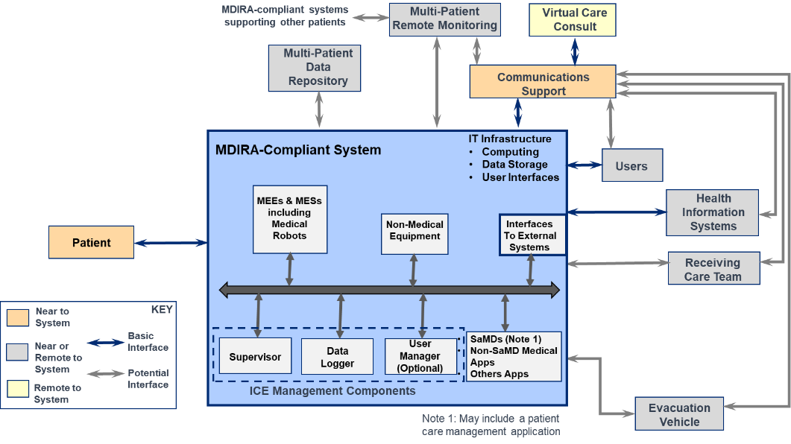

Components included in the “blue” MDIRA-Compliant System box represent the core actors that would be included in this IHE MDIRA Profile (see New Actors below); whereas, the systems outside would be represented by external actors that in most cases, may be implemented using other IHE technical framework profiles.

**New actors**

The following MDIRA Actor Model is based on the above MDIRA component model and the approach taken for the SDPi profiles (see below):

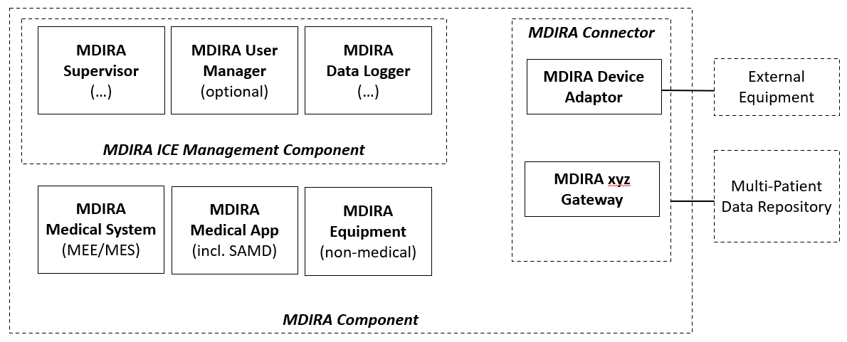

[Editor’s Notes:

1. Similarly to the SDPi profile that adds “SOMDS” to the name of each actor – primarily because some of the actors are otherwise present in other IHE profiles – the proposed model above includes “MDIRA”. Note that these actors end up in the IHE TF 0 appendix with all the actors from all the profiles … so this convention is a good thing … especially down the road!
2. The actor model does not show connections or specific transactions between MDIRA components, in a similar way to SDPi and for the same reasons. Some connection should be shown though … somehow …
3. “ICE Management Components” are included as an abstract actor; however, is there anything really there there? This is as opposed to the MDIRA Component abstract actor that may be married to the SOMDS Participant actor to provide the core functionality needed by all the MDIRA actors
4. MDIRA Connector (aligned with SOMDS Connector below) represents the “Interfaces to External Systems” component above.
5. MDIRA User Manager “optionality” is indicated as a note since it is so noted on the components model; however, optionality is handled differently in IHE profiles. The question of what exactly does a User Manager do is still open to discussion here …
6. Not all “external” components are included in this Actor Diagram; what to include where is the subject of further discussion; this could be done as “external MDIRA systems” and then have a table or other discussion within the profile specification covering the various topics above.
7. Device? MEE? MES? Medical Robot? Regulated / non-regulated? The group should think through the best way to refer to these distinctions and even IF to make these distinctions.
8. MDIRA Medical App would be tied to the same “external” actor in the SDPi-P model (below) but not explicitly called out here are Therapy Coordinator App or CLC, etc.

]

**Existing actors**

The MDIRA profile will heavily leverage the SDPi profiles, including the following SDPi-Plug-and-trust actors:

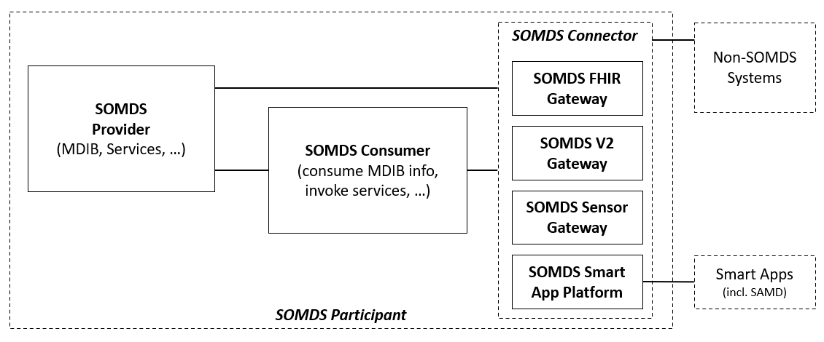

Figure IHE SDPi-P Actor Model

Actors from other SDPi profiles (-R, -A & -xC) may also be included as well as from other IHE profiles depending on the external actors defined in the MDIRA profile.

**New transactions (standards used)**

[Editor’s Note: This will be **leveraged from the MDIRA 2.0 specification** and balanced with the detail in SDPi profiles – leveraging as much detail “under the hood” from SDPi to make the MDIRA “value add” layer clear. For example, though a device may work fine in an SDC and SDPi SOMDS, it may detect at plug-and-trust that it is part of a MDIRA SOMDS and thus discover and connect with that network’s Supervisor first. This would require a new transaction and use case scenario]

~~<Describe possible new transactions (indicating what standards would likely be used for each. Transaction diagrams are very helpful here. Feel free to go into as much detail as seems useful.>~~

~~<Point out any key issues or design problems. This will be helpful for estimating the amount of work.>~~

~~<If a phased approach would make sense indicate some logical phases. This may be because standards are evolving, because the problem is too big to solve at once, or because there are unknowns that won’t be resolved soon.>~~

~~<Indicate how existing / /transactions might need to be modified.>~~

**Impact on existing integration profiles**

Since the use contexts for MDIRA are similar (high acuity point-of-care) but also different (e.g., geographically remote, autonomous medical systems, telemedicine connections, etc.) some additional capability may need to be added to the underlying profiles, such as SDPi-P. For example, an SDPi-P Option for “Remote Connection” leveraging HTTP/2 and gRPC technologies for a transport better suited (and supported) across cloud infrastructure, may be required.

Additionally, implementation priority may need to be adjusted for completion of optional capabilities for the SDPi profiles or the related Devices on FHIR implementation guides.

Finally, though great effort has been made to ensure that the SDPi profiles can be leveraged by other profiles, such as MDIRA, the “proof is in the pudding” and MDIRA profiling may uncover the need to rethink some of the approaches and capabilities included in SDPi.

**New integration profiles needed**

~~<Indicate how existing profiles might need to be modified~~.> **THIS COMMENT MAKES NO SENSE**

**Breakdown of tasks that need to be accomplished**

~~<A list of tasks would be helpful for the technical committee who will have to estimate the effort required to design, review and implement the profile.>~~

[Editor’s Note: this can be included toward the end of the DPP drafting and review]

# Risks

[Editor’s Note:

1. Continued MDIRA project (or related) funding beyond 2021 June.
2. Completion of the underlying SDPi+FHIR profiles
3. Open Source tools and test tooling
4. Clear value proposition for industry to adopt and implement MDIRA compliant technology … including “market demand”
5. …

]

# Open Issues

[Editor’s Note:

1. Consensus on the capabilities and implementation approach for various of the MDIRA actors and capabilities; ensuring that implementation can significantly leverage the work already accomplished or in process by the product implementation community;
2. How MDIRA conformity will be determined so as to ensure that MDIRA Profile implementations can be tested, CA’d and certified as compliant.
3. Maturity and implementatableness of underlying specifications
4. …

]

# Effort Estimates

~~<The technical committee will use this area to record details of the effort estimation.>~~

[Editor’s Note: Near term intent is to complete to say 80% by end of May 2021. Actual completion dates depend on resources and completion of the underlying SDPi supplement details.]